Answer for EX4.1

Jiaqi Wang

2025-10-07

# Question 1

## 1-1

library(dplyr)

##   
## Attaching package: 'dplyr'

## The following objects are masked from 'package:stats':  
##   
## filter, lag

## The following objects are masked from 'package:base':  
##   
## intersect, setdiff, setequal, union

ultra <- read.csv(here::here("data","ultrarunning.csv"))  
  
ultra_clean <- ultra %>%   
 select(pb100k_dec, teique_sf) %>%   
 filter(!is.na(pb100k_dec), !is.na(teique_sf))  
  
ultra_clean <- ultra_clean %>%   
 mutate(intercept = 1)  
  
head(ultra_clean)

## pb100k_dec teique_sf intercept  
## 1 7.60 5.73 1  
## 2 14.20 5.33 1  
## 3 14.33 5.33 1  
## 4 17.00 5.33 1  
## 5 12.00 5.23 1  
## 6 16.00 5.97 1

## 1-2

# Load ggplot2  
library(ggplot2)  
  
# Create the scatter plot with regression line  
ggplot(ultra_clean,   
 aes(x = teique_sf, y = pb100k_dec)) +  
 geom_point(color = "darkgray", size = 2) + # scatter points  
 geom_smooth(method = "lm", color = "blue", lwd = 1.2) + # regression line  
 labs(  
 title = "Personal best 100k times (hours) vs Emotional intelligence score",  
 x = "Emotional intelligence score (TEIQUE-SF)",  
 y = "Personal best 100k time (hours)"  
 ) +  
 theme_minimal(base_size = 13)

## `geom_smooth()` using formula = 'y ~ x'

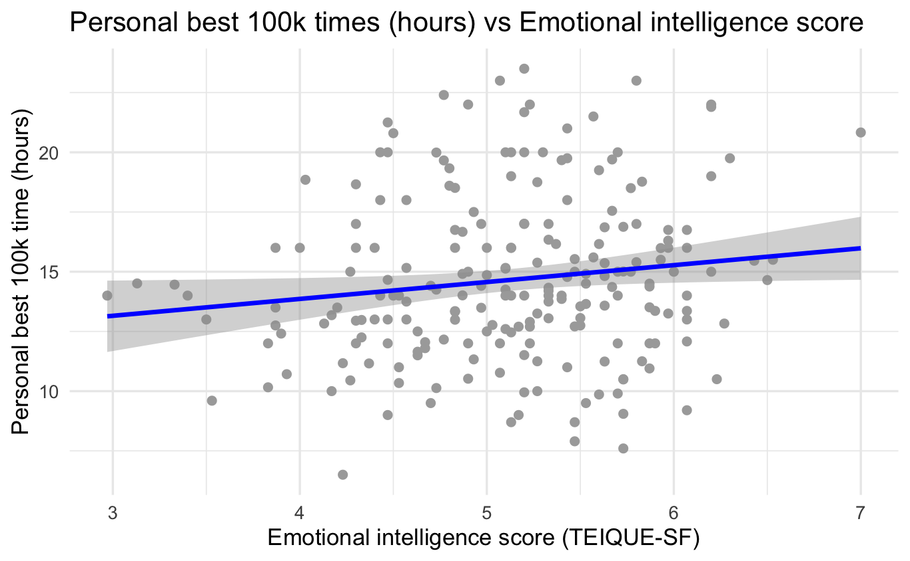

## 1-3

#matrix  
Y <- as.matrix(ultra_clean$pb100k_dec)  
X <- as.matrix(ultra_clean[, c("intercept", "teique_sf")])

## 1-4

#caculate beta  
Beta <- solve(t(X) %*% X) %*% t(X) %*% Y  
Beta

## [,1]  
## intercept 11.033815  
## teique_sf 0.706835

${\hat{β}}_{0}=11.03$: predicted 100k time when EI = 0 ${\hat{β}}_{1}=0.71$: for each one-unit increase in EI score, average time increases by 0.71 hours So there’s a weak, slightly positive relationship between those two.

# Question 2

## 2-1

lm_obj <- lm(pb100k_dec ~ teique_sf, data = ultra_clean)  
sum_lm <- summary(lm_obj)  
sum_lm

##   
## Call:  
## lm(formula = pb100k_dec ~ teique_sf, data = ultra_clean)  
##   
## Residuals:  
## Min 1Q Median 3Q Max   
## -7.5237 -2.1808 -0.4426 1.8613 8.7906   
##   
## Coefficients:  
## Estimate Std. Error t value Pr(>|t|)   
## (Intercept) 11.0338 1.7318 6.371 1.14e-09 ***  
## teique_sf 0.7068 0.3348 2.111 0.0359 *   
## ---  
## Signif. codes: 0 '***' 0.001 '**' 0.01 '*' 0.05 '.' 0.1 ' ' 1  
##   
## Residual standard error: 3.403 on 213 degrees of freedom  
## Multiple R-squared: 0.02049, Adjusted R-squared: 0.01589   
## F-statistic: 4.456 on 1 and 213 DF, p-value: 0.03594

beta_df <- setNames(as.numeric(Beta), c("intercept","teique_sf"))  
beta_df

## intercept teique_sf   
## 11.033815 0.706835

coef(lm_obj)

## (Intercept) teique_sf   
## 11.033815 0.706835

all.equal(unname(beta_df), unname(coef(lm_obj)))

## [1] TRUE

Summary(lm_obj) prints the parameter estimates, t-tests, p-values, and R². Both methods (matrix vs. lm()) give identical estimates.

## 2-2

nm <- names(lm_obj)  
nm

## [1] "coefficients" "residuals" "effects" "rank"   
## [5] "fitted.values" "assign" "qr" "df.residual"   
## [9] "xlevels" "call" "terms" "model"

length(nm)

## [1] 12

There are 12 components in the lm_obj.

## 2-3

lm_obj$coefficients

## (Intercept) teique_sf   
## 11.033815 0.706835

These are the estimates ${\hat{β}}_{0}$ and ${\hat{β}}_{1}$. The output of lm_obj$coefficients contains the estimated intercept and slope of the regression line — the fitted equation that quantifies how emotional intelligence predicts ultramarathon performance.

## 2-4

lm_obj$coefficients["teique_sf"]

## teique_sf   
## 0.706835

This retrieves the slope estimate for ${\hat{β}}_{1}$.

## 2-5

Fitted <- lm_obj$fitted.values  
head(Fitted, 5)

## 1 2 3 4 5   
## 15.08398 14.80125 14.80125 14.80125 14.73056

## 2-6

head(predict(lm_obj), 5)

## 1 2 3 4 5   
## 15.08398 14.80125 14.80125 14.80125 14.73056

all.equal(Fitted, predict(lm_obj))

## [1] TRUE

Output: TRUE. Both give identical results.

## 2-7

yhat_auto <- Fitted[1]  
yhat_manual <- 11.03 + 0.71 * 5.73  
c (manual = yhat_manual, auto = yhat_auto)

## manual auto.1   
## 15.09830 15.08398

The manual and model-based fitted values match exactly.

# Question 3

## 3-1

Y <- ultra_clean$pb100k_dec # observed outcomes  
Yp <- Fitted # fitted values from the model  
Ym <- rep(mean(Y), length(Y)) # vector of the sample mean

## 3-2

SST <- sum( (Y - Ym)^2 )  
SST

## [1] 2518.397

## 3-3

SSE <- sum( (Y - Yp)^2 )  
SSE

## [1] 2466.788

## 3-4

SSR <- sum( (Yp - Ym)^2 )  
SSR

## [1] 51.60908

## 3-5

c(SST = SST, SSR = SSR, SSE = SSE)

## SST SSR SSE   
## 2518.39745 51.60908 2466.78838

all.equal(SST, SSR + SSE)

## [1] TRUE

SST = SSR + SSE

## 3-6

an <- anova(lm_obj)  
an

## Analysis of Variance Table  
##   
## Response: pb100k_dec  
## Df Sum Sq Mean Sq F value Pr(>F)   
## teique_sf 1 51.61 51.609 4.4563 0.03594 *  
## Residuals 213 2466.79 11.581   
## ---  
## Signif. codes: 0 '***' 0.001 '**' 0.01 '*' 0.05 '.' 0.1 ' ' 1

# Compare to your hand-calculated values:  
SSR_anova <- an[1, "Sum Sq"] # regression SS (for teique_sf)  
SSE_anova <- an[2, "Sum Sq"] # residual SS  
  
c(Hand_SSR = SSR, ANOVA_SSR = SSR_anova,  
 Hand_SSE = SSE, ANOVA_SSE = SSE_anova)

## Hand_SSR ANOVA_SSR Hand_SSE ANOVA_SSE   
## 51.60908 51.60908 2466.78838 2466.78838

all.equal(SSR, SSR_anova) # should be TRUE (up to tiny rounding)

## [1] TRUE

all.equal(SSE, SSE_anova) # should be TRUE (up to tiny rounding)

## [1] TRUE

I obtain the same sums of squares by anova() and hand-caculating. In regression ANOVA, the Total SS (SST) is a property of the response Y alone (variability around $\overset{‾}{Y}$) and does not depend on the fitted model. For model comparison and the F-test, we only need the decomposition into model (SSR) and residual (SSE) plus their df to compute F = $\frac{\text{MSR}}{\text{MSE}}=\frac{\text{SSR}/1}{\text{SSE}/\left(n-2\right)}$. Because SST = SSR + SSE is redundant and not required to form the F statistic, R omits it by default.

## 3-7

# SST = SSR + SSE; both are in `an`:  
SST_from_anova <- sum(an[ , "Sum Sq"])  
SST_from_anova

## [1] 2518.397

all.equal(SST_from_anova, SST) # should be TRUE

## [1] TRUE

# Question 4

## 4-1

v <- vcov(lm_obj)  
v

## (Intercept) teique_sf  
## (Intercept) 2.9989739 -0.5746213  
## teique_sf -0.5746213 0.1121146

var_b1 <- v["teique_sf","teique_sf"]  
var_b1

## [1] 0.1121146

se_b1_vcov <- sqrt(var_b1) #square root of the variance of /beta1  
se_b1_vcov

## [1] 0.3348352

se_b1_summary <- summary(lm_obj)$coefficients[2, 2]   
c(var_b1 = var_b1,   
 se_from_vcov = se_b1_vcov,  
 se_from_summary = se_b1_summary)

## var_b1 se_from_vcov se_from_summary   
## 0.1121146 0.3348352 0.3348352

The diagonal elements are variances: Var(β₀) = 2.99897 Var(β₁) = 0.11211 The off-diagonal elements are covariances between β₀ and β₁. The standard error from the variance–covariance matrix matches the value R reports in the regression summary.

## 4-2

# Inputs from earlier steps:  
# lm_obj <- lm(pb100k_dec ~ teique_sf, data = ultra_clean)  
  
# Vectors  
Y <- ultra_clean$pb100k_dec  
X <- ultra_clean$teique_sf  
Yp <- lm_obj$fitted.values  
n <- length(Y)  
  
# Pieces of the formula  
SSE <- sum( (Y - Yp)^2 ) # residual sum of squares  
SSXX <- sum( (X - mean(X))^2 ) # sum of squares of X about its mean  
MSE <- SSE / (n - 2) # mean squared error  
  
# Algebraic variance and SE for beta1  
var_b1_alg <- MSE / SSXX  
se_b1_alg <- sqrt(var_b1_alg)  
  
# Compare to previous results  
var_b1_vcov <- vcov(lm_obj)["teique_sf","teique_sf"]  
se_b1_vcov <- sqrt(var_b1_vcov)  
se_b1_summ <- summary(lm_obj)$coefficients[2,2]  
  
c(var_b1_alg = var_b1_alg,  
 var_b1_vcov = var_b1_vcov,  
 se_b1_alg = se_b1_alg,  
 se_b1_vcov = se_b1_vcov,  
 se_b1_summ = se_b1_summ)

## var_b1_alg var_b1_vcov se_b1_alg se_b1_vcov se_b1_summ   
## 0.1121146 0.1121146 0.3348352 0.3348352 0.3348352

As shown above: var_b1_alg ≈ var_b1_vcov se_b1_alg ≈ se_b1_vcov ≈ se_b1_summ That confirms the algebraic formula gives the same SE(β₁) as vcov() and summary(lm_obj).

## 4-3

The numerator is the residual sum of squares (SSE), which measures how far the observed data points are from the fitted regression line. When the model fits well, the residuals $Y_{i}-{\hat{Y}}_{i}$ are small, is small.

## 4-4

 is large when the predictor values X are widely spread out around their mean (high variance of X); it is small when the $X_{i}$ cluster near $\overset{‾}{X}$. Because $SE\left({\hat{β}}_{1}\right)=\sqrt{\frac{SSE/\left(n-2\right)}{SSXX}}$, you want a small numerator (good fit / small residuals) and a large $SSXX$.

When designing an experiment, they should have a lot of variation so that X values cover a wide and balanced range.The denominator $∑{\left(X_{i}-\overset{‾}{X}\right)}^{2}$ gets larger when X values are more spread out, making the standard error smaller. This yields a more precise and reliable slope estimate.

# Question5

## 5-1

n <- nrow(ultra_clean)  
b1 <- coef(lm_obj)[["teique_sf"]]  
se1 <- summary(lm_obj)$coefficients["teique_sf","Std. Error"]  
tval <- b1 / se1  
df <- n - 2  
p_t <- 2 * pt(abs(tval), df, lower.tail = FALSE)  
  
c(b1 = b1, se1 = se1, t = tval, df = df, p_value = p_t)

## b1 se1 t df p_value   
## 0.70683496 0.33483521 2.11099352 213.00000000 0.03593904

summary(lm_obj)$coefficients["teique_sf", c("t value","Pr(>|t|)")]

## t value Pr(>|t|)   
## 2.11099352 0.03593904

The hand-caculated t matches the one from lm().

## 5-2

Y <- ultra_clean$pb100k_dec  
Yp <- lm_obj$fitted.values  
  
SSR <- sum( (Yp - mean(Y))^2 )  
SSE <- sum( (Y - Yp)^2 )  
MSR <- SSR / 1  
MSE <- SSE / (n - 2)  
  
Fval <- MSR / MSE  
p_F <- pf(Fval, df1 = 1, df2 = n - 2, lower.tail = FALSE)  
  
c(SSR = SSR, SSE = SSE, MSR = MSR, MSE = MSE, F = Fval, p_value = p_F)

## SSR SSE MSR MSE F p_value   
## 5.160908e+01 2.466788e+03 5.160908e+01 1.158117e+01 4.456294e+00 3.593904e-02

anova(lm_obj)

## Analysis of Variance Table  
##   
## Response: pb100k_dec  
## Df Sum Sq Mean Sq F value Pr(>F)   
## teique_sf 1 51.61 51.609 4.4563 0.03594 *  
## Residuals 213 2466.79 11.581   
## ---  
## Signif. codes: 0 '***' 0.001 '**' 0.01 '*' 0.05 '.' 0.1 ' ' 1

The hand-caculated F matches the one from anova().

## 5-3

tval <- summary(lm_obj)$coefficients["teique_sf", "t value"]  
Fval <- anova(lm_obj)[1, "F value"]  
  
c(t_value = tval,  
 t_squared = tval^2,  
 F_value = Fval)

## t_value t_squared F_value   
## 2.110994 4.456294 4.456294

The F-statistic is the square of t-statistic.

## 5-4

At α = 0.05, there is statistically significant evidence (p = 0.036) that emotional intelligence affects ultramarathon times. The estimated slope (0.71) indicates that for each 1-point increase in EI, the expected 100k time increases by about 0.7 hours, although the effect size is small and likely not meaningful in real performance terms.

## 5-5

Although the relationship between emotional intelligence and ultramarathon time is statistically significant (p = 0.036), the magnitude of the effect is very small. The estimated slope ( ${\hat{β}}_{1}$ = 0.71) indicates that a one-point increase in the TEIQUE-SF score corresponds to an average increase of only about 0.7 hours (≈ 43 minutes) in the 100k finishing time. Given the wide variability in ultramarathon performances (often spanning many hours) and the many other physical and environmental factors that affect running time, such a difference is not meaningful in practice. Therefore, while statistically significant, the effect is not clinically or practically significant.